Potential new treatment for cocaine addiction

*31 August 2016*

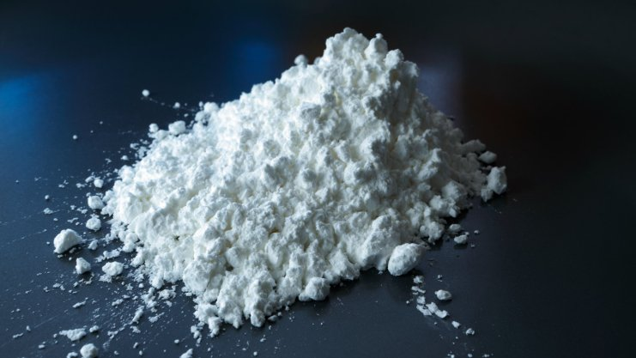

*A team of researchers led by Cardiff University has discovered a promising new drug treatment for cocaine addiction.*

The experimental therapy, which involves administering a drug currently used in cancer therapy trials, treats cocaine addiction by inhibiting memories responsible for cravings.

Professor Riccardo Brambilla from Cardiff University’s School of Biosciences said: “We have demonstrated that a single administration of a trial drug from the pharmacompany Pfizer can completely obliterate cocaine associated memories and significantly accelerate the end of drug seeking behaviour in animals. With this drug currently being used in cancer trials, it could be easily repositioned for treatment of cocaine addiction and other drugs of abuse.”

Cocaine produces its addictive effects partially by acting on the brain’s limbic system - a set of interconnected regions that regulate pleasure and motivation. When a person uses cocaine, memories of the intense pleasure felt and the things associated with it are newly created. It is these long lasting memories and drug-associated cues, key to the transition from recreational drug taking to compulsive drug use, which the new treatment inhibited when tested on mice.

Dr Stefania Fasano from Cardiff University added, “With drug use recently on the rise, new treatments for breaking addiction are much needed. The availability of a powerful drug from Pfizer, already validated in humans, could speed up the clinical development of our findings.”

The research is published in the journal *[eLife](https://elifesciences.org/content/5/e17111)*[.](https://elifesciences.org/content/5/e17111)

This was an experimental study in mice, which allows for conclusions to be made about cause and effect in this species. To learn about the effect of this treatment in people experimental trials with humans will be necessary.